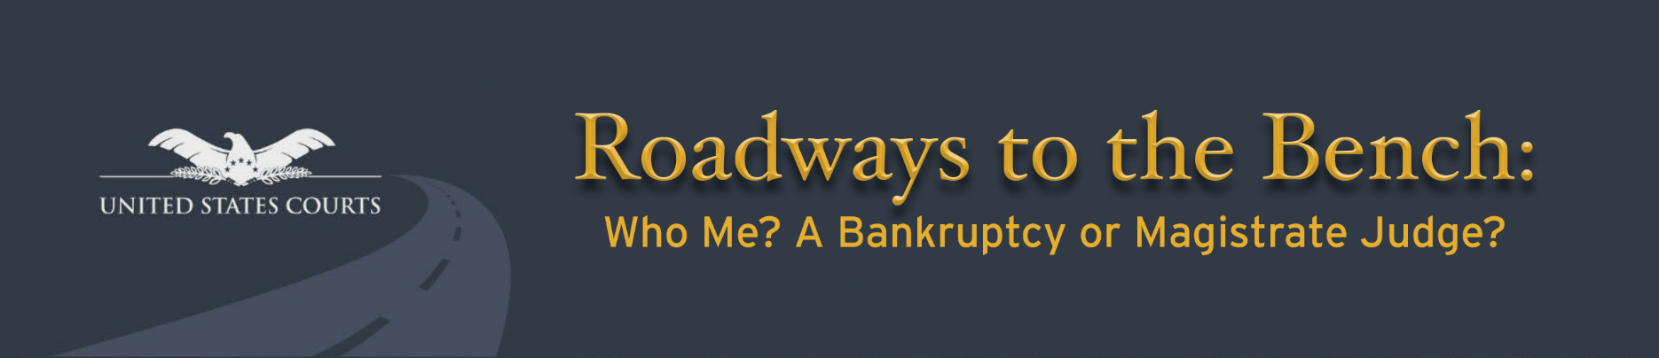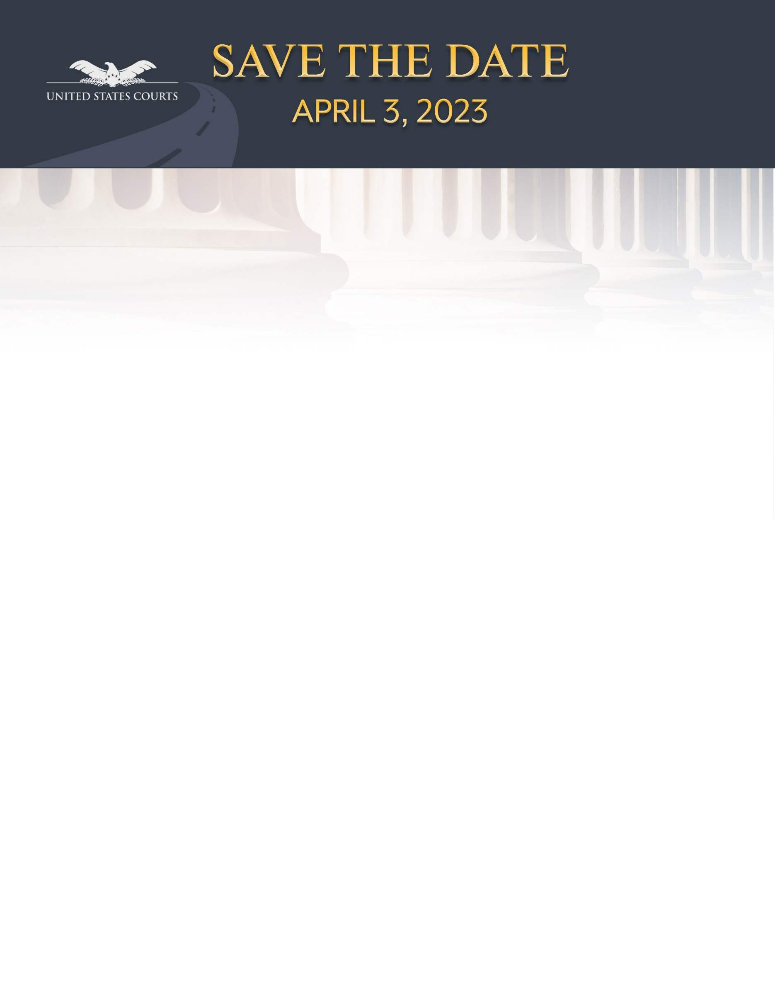

To further the goal of casting a wide net to attract the broadest possible pool of qualified applicants to serve as federal judges, the Judicial Conference Committees on the Administration of the Bankruptcy System and Magistrate Judges System present their national diversity event:

***ROADWAYS to the BENCH: Who Me? A Bankruptcy or Magistrate Judge?***

**Date:** April 3, 2023 at 4:00 p.m. – Reception Follows

**Location:** Carl B. Stokes United States Courthouse

801 W. Superior Ave., Cleveland, OH

* Interested lawyers and law students will observe a nationally live-streamed panel discussion and participate in on-site roundtable discussions with bankruptcy, magistrate, and district judges about pathways to the federal bench.
* Registration is Now Open! Submit a Registration Request **by** **March 20, 2023** to [2023rtbcleveland@ohnb.uscourts.gov](mailto:2023rtbcleveland@ohnb.uscourts.gov). Registration will be limited due to space constraints. After registration closes, full details and instructions will be emailed to confirmed attendees.

**Registration Request**

Name: Click to enter First Name, Middle Initial, Last Name

Email: Click to enter email address

Employer or Law School: Click to enter email address

Law School Graduation Year or Anticipated Graduation Date: Click or tap to enter a date.

Telephone Number: Click to enter phone number

How You Learned About the Event: Click to list how you learned about the Roadways event

Bar Association or Student Group Affiliations: Click or tap here to list your associations

***Registrants are asked to consider submitting the accompanying voluntary demographic data identification form, which may also be returned to the email address below.***

**For more information or to return completed form(s), please contact the**

**Cleveland, OH planning committee at:** [2023RTBCleveland@ohnb.uscourts.gov](mailto:2023RTBCleveland@ohnb.uscourts.gov)