000000000000000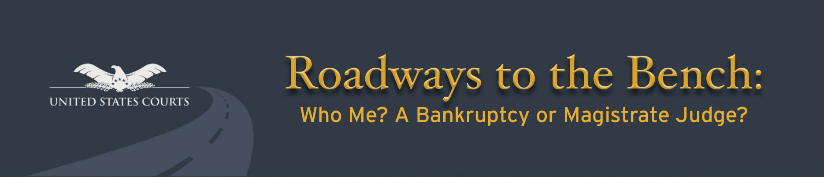

**VOLUNTARY RACE/ETHNICITY, GENDER, & DISABILITY IDENTIFICATION**

Demographic information is being solicited to assess the effectiveness of current outreach efforts and inform future outreach activities that will attract the broadest possible pool of lawyers and law students to attend this judiciary-wide diversity event. Your furnishing of this information is voluntary. There will be no impact on your request to register for Roadways to the Bench if you choose not to complete this form.

**Specific Instructions:** Please anonymously identify your gender, disability status, and ethnicity. Select the race/national origin category with which you most closely identify. You may select more than one race/national origin category.

1. Event: ***Roadways to the Bench: Who Me? A Bankruptcy or Magistrate Judge?***

2. Event Location: ***Cleveland, Ohio April 3, 2023***

3. Gender: Female  Male  Non-binary

4. Disability:  Yes  No

5. First Generation College or Law Student:  Yes  No

6. Veteran:  Yes  No

7. Ethnicity:  Hispanic Latino/a  Non-Hispanic Origin

8. Race / National Origin: (*select all that apply*)

|  |
| --- |
| Indigenous American Indian or Alaska Native |
| Asian/Asian American |
| Black/African American |
| Native Hawaiian or Pacific Islander |
| White/Caucasian |
| Middle Eastern/Arab American |
| Indian Subcontinent |
| Other: ______________________________ |

6. Ethnicity: Hispanic

elect all that apply)

Origin

’ American Indian or Alaska Native

’ Asian

A person having origins with any of the original peoples of North and South America (including

Central America) and who maintain tribal affiliation or community attachment. It includes people

who identify as "American Indian" or "Alaska Native" and includes groups such as Navajo Nation,

Blackfeet Tribe, Mayan, Aztec, Native Village of Barrow Inupiat Traditional Government, and Nome

Eskimo Community.

A person having origins in any of the original peoples of the Far East, Southeast Asia, or the

Indian subcontinent, including, for example, Cambodia, China, India, Japan, Korea, Malaysia,

Pakistan, the Philippine Islands, Thailand, or Vietnam.

’ Black/African American

A person having origins in any of the black racial groups in

Africa.

’ Native Hawaiian or Pacific Islander

A person having origins in any of the original peoples of Hawaii, Guam, Samoa, or other Pacific

Islands.

’ White/Caucasian

A person having origins in any of the original peoples of Europe, North Africa, or the Middle East.

’ Some Other Race

A person who does not identify with any of the provided race categories.

For Office Use Only:

Department ID

**For more information, please contact the Cleveland, OH planning committee at** [2023RTBCleveland@ohnb.uscourts.gov](mailto:2023RTBCleveland@ohnb.uscourts.gov)